**Review comments**

**Reviewer 1:**

With great interest I've read this really interesting paper on macrolide resistance genes. The authors have written a very good paper. The research has some important limitation, but the authors have all discussed them in the "discussion" session. Therefore, I have only a few less important remarks:

1. Do the authors have data or literature to support the statement in the Methods that a 6 month “wash-out” is enough to go back to a “baseline” situation?

**[Literature search]: macrolide resistance gene at specific time points after treatment**

1. In our AZM study, majority of participants (84%, 157/186) do not have any regular antibiotic history
2. **Malhotra’s paper** is the only randomised controlled trial I can find to examine macrolide resistance gene at specific time points after antibiotic treatment
   1. Receive azithromycin/clarithromycin for 3/7 days, measure resistance gene carriage for 180 days
   2. Macrolide resistance genes: mef, ermB, tetO, tetM, tetL, tetK, ermA
   3. Carriage of tet(L), tet(K), and erm(A) remained the stable throughout the study period
   4. 6-month post macrolide therapy, carriage of the rest genes significantly dropped, went back to the level that close to baseline

**Other papers:** compare the resistance gene carriage with placebo group or during therapy

(e.g. Jocelyn erythromycin paper and Steven’s azithromycin paper or Remco’ paper)



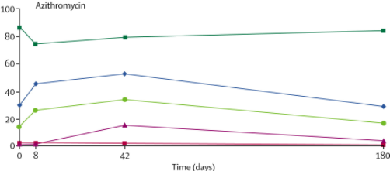

1. Costelloe 2010 BMJ:Meta-analysis paper (PMID: 20483949)
   1. At 6 months post-antibiotic, the antibiotic use is not significantly associated with resistance anymore

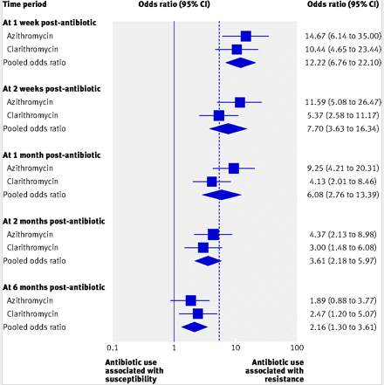

**[Our response]**

1. The authors have a 4-week wash-out for other antibiotics but how about e.g. clindamycin (Lincosamides) in this erm setting?

**[Contact Lucy]**

From the clinical manifest, none of the participants received clindamycin during the 4-week wash-out,

To be safe, I have checked this question with three clinicians. However, only Rachel Thompson confirmed it. It is worthy confirm this at the future zoom meeting.

**[Our response]**

Yes, none of the participants have received clindamycin during the 4-week wash-out period

1. In the cohort overview results, the authors mention a 12-month interval used for macrolide as an exclusion but in the methods it’s 6 months. Could the authors explain this discrepancy?

**[Answer to this question]**

1. My guess on why index patients receiving clarithromycin was excluded by Lucy B

Clarithromycin is one type of macrolides; however, when we first start this project (AZM/SERPAT), is focused on Azithromycin (AZM+SERPAT) and erythromycin (SERPAT), therefore the index patients receiving clarithromycin were excluded by Lucy.

1. Confirmation with Lucy

I have put forward this question in the spreadsheet, however, Lucy did not answer. It is worthy confirm this at the future zoom meeting

**[Geraint’s question]**

*Were any patients excluded because they received clarithromycin between 6-12 months

- Yes

* 1. In the initial AZM clinical manifest, two index patients (NC014 and NA008) were excluded by Lucy as they are on clarithromycin last 12 months
  2. This is the reason when I describe how we recruit patients, I wrote 2 patients were excluded due to clarithromycin usage in the last 12 months; but in our recruitment details (online supplement), we did not mention about clarithromycin, which confused the reviewer
  3. In our online supplement, we wrote “NMR: Is not currently on azithromycin/erythromycin maintenance therapy and has not received any macrolide antibiotics in the prior 6 months”, reviewer saw the 12 months and confused about the exclusion intervals; however, the key to the answer is “clarithromycin” not “interval”

*Were any patients included because they received clarithromycin between 6-12 months

- No

* 1. AZM samples: checked
  2. SERPAT samples: checked
  3. Concord samples: 1 sample (Concord 009) said received clarithromycin or azithromycin in the last year but did not clarify which one
  4. Rachel samples: checked

1. Could the authors give more detail on the relationship between patients and controls? Are they siblings or spouses or others? This might influence contact. I imagine that transmission risk is different between a friend you see frequently or your sibling or your partner… Do the authors have details and could this have influenced the data (e.g. more similarity between partner vs friends?)

**[Task]**

1. For missing data, contact clinicians: Done
2. Description of relationship details (Table)
3. Transmission risk is affected by relationship or not

Table 1. Summary of relationship details in this study

|  |  |  |  |  |  |  |  |  |  |
| --- | --- | --- | --- | --- | --- | --- | --- | --- | --- |
| **Relationship** | **Overall** | | | **Macrolide recipient group** | | | **Macrolide non-recipient group** | | |
| **Number** | **Total number** | **Percentage (%)** | **Number** | **Total number** | **Percentage (%)** | **Number** | **Total number** | **Percentage (%)** |
| Friend | 3 | 93 | 3.2 | 1 | 53 | 1.9 | 2 | 40 | 5.0 |
| Parent-child | 29 | 31.2 | 19 | 35.8 | 10 | 25.0 |
| Partner | 59 | 63.4 | 32 | 60.4 | 27 | 67.5 |
| Sibling | 2 | 2.2 | 1 | 1.9 | 1 | 2.5 |

Table 2. Relationship effect on transmission risk of macrolide resistance genes

|  |  |  |
| --- | --- | --- |
| **Resistance gene** | **Partner vs Parent-child** | |
| **Odds ratio (95% CI)** | ***P* value** |
| *erm*(A) | 1.0  (0-Inf) | >0.99 |
| *erm*(B) | 0.8  (0.2-2.4) | 0.63 |
| *erm*(C) | 1.2 × 108  (0-Inf) | >0.99 |
| *erm*(F) | 1.3  (0.5-3.6) | 0.59 |
| *mef* | 2.5  (0.9-6.7) | 0.08 |
| *msr*(A) | 1.0  (0.2-4.1) | >0.99 |
| *msr*(E) | 0.8  (0.3-2.2) | 0.66 |
| *tet*(M) | 0.3  (0.04-2.8) | 0.30 |
| *tet*(O) | 1.2  (0.4-3.1) | 0.77 |
| *tet*(W) | 0.6  (0.2-1.9) | 0.41 |

**Reviewer 2:**

Wang and colleagues seek to assess whether long-term macrolide therapy poses a risk for onward transmission of resistance genes in patients with chronic respiratory disease and their co-inhabitants. Though limited in scope (focusing on a select number of macrolides + tetracycline genes by qPCR), I can’t fault the technical execution of the molecular methods presented. I have some concerns about the experimental design, analysis, and conclusions.

1. That the relative abundance of ermB is higher in MR and MNR group. However, they also tested 9 additional resistance genes (multiple hypothesis testing) and I don’t see where this has been adjusted for. With adjustment, significance will probably be lost.

**[Pre and post FDR results]**

**Table 2.** Resistance gene detection frequency in patients stratified by macrolide use.

|  |  |  |  |  |
| --- | --- | --- | --- | --- |
| **Resistance gene** | **MR** | **MNR** | ***P* values** | ***P* values**  **(post-FDR)** |
| *erm*(A) | 3.8%  (2/53) | 5.0%  (2/40) | 0.99 | 0.99 |
| *erm*(B) | 89%  (47/53) | 95%  (38/40) | 0.46 | 0.66 |
| *erm*(C) | 19%  (10/53) | 13%  (5/40) | 0.57 | 0.71 |
| *erm*(F) | 68%  (36/53) | 78%  (31/40) | 0.36 | 0.62 |
| *mef* | 74%  (39/53) | 83%  (33/40) | 0.33 | 0.62 |
| *msr*(A) | 36%  (19/53) | 25%  (10/40) | 0.37 | 0.62 |
| *msr*(E) | 66%  (35/53) | 73%  (29/40) | 0.65 | 0.72 |
| *tetM* | 94%  (50/53) | 100%  (40/40) | 0.26 | 0.62 |
| *tetO* | 64%  (34/53) | 78%  (31/40) | 0.18 | 0.62 |
| *tetW* | 85%  (45/53) | 98%  (39/40) | 0.07 | 0.62 |

**Table 3.** Normalised resistance gene abundance in patients stratified by macrolide use.

|  |  |  |  |  |
| --- | --- | --- | --- | --- |
| **Resistance gene** | **MR** | **MNR** | ***P* values** | ***P* values**  **(post-FDR)** |
| *erm*(A) | 0  (0.0-10.5) | 0  (0.0-7.1) | 0.39 | 0.99 |
| *erm*(B) | 7.5  (0.0-12.4) | 6.9  (0.0-10.8) | 0.045 | 0.66 |
| *erm*(C) | 0  (0.0-13.2) | 0  (0.0-8.0) | 0.14 | 0.71 |
| *erm*(F) | 7.6  (0.0-12.4) | 6.2  (0.0-11.9) | 0.22 | 0.62 |
| *mef* | 4.4  (0.0-6.7) | 3.9  (0.0-7.5) | 0.20 | 0.62 |
| *msr*(A) | 0  (0.0-13.2) | 0  (0.0-9.1) | 0.15 | 0.62 |
| *msr*(E) | 7.3  (0.0-13.0) | 5.7  (0.0-15.9) | 0.07 | 0.72 |
| *tetM* | 5.9  (0.0-8.9) | 5.5  (2.1-7.6) | 0.42 | 0.62 |
| *tetO* | 6.4  (0.0-10.5) | 6.3  (0.0-12.3) | 0.39 | 0.62 |
| *tetW* | 5.2  (2.7) | 4.8  (2.2) | 0.46 | 0.62 |

**Table 4.** Paired assessment of the resistance gene detection frequency between patients and close contacts stratified by macrolide use.

|  |  |  |  |  |  |  |
| --- | --- | --- | --- | --- | --- | --- |
| **Resistance gene** | **MR vs MRCC** | | | **MNR vs MNRCC** | | |
| **Odds ratio**  **(95% CI)** | ***P* value** | ***P* values**  **(post-FDR)** | **Odds ratio**  **(95% CI)** | ***P* value** | ***P* values**  **(post-FDR)** |
| *erm*(B) | 3.4  (0.5-22.9) | 0.21 | 0.38 | 1.3×10-7  (0-Inf) | >0.99 | 0.99 |
| *erm*(C) | 5.1  (0.6-41.9) | 0.13 | 0.29 | 8.5  (0.4-163.9) | 0.16 | 0.99 |
| *erm*(F) | 11.8  (2.3-59.6) | 0.0029 | 0.020 | 1.7  (0.4-7.6) | 0.50 | 0.99 |
| *mef* | 7.3  (1.9-28.4) | 0.0044 | 0.020 | 1.3  (0.3-6.9) | 0.75 | 0.99 |
| *msr*(A) | 1.5  (0.5-4.9) | 0.48 | 0.62 | 1.8  (0.4-8.2) | 0.43 | 0.99 |
| *msr*(E) | 0.8  (0.3-2.7) | 0.74 | 0.83 | 1.1  (0.3-4.5) | 0.87 | 0.99 |
| *tetM* | 2.1×10-7  (0-Inf) | >0.99 | 0.99 | N/A | N/A | N/A |
| *tetO* | 2.7  (0.8-8.5) | 0.099 | 0.29 | 1.7  (0.4-7.6) | 0.50 | 0.99 |
| *tetW* | 2.4  (0.5-12.0) | 0.29 | 0.44 | 2.5×10-7  (0-Inf) | >0.99 | 0.99 |

**Table 5.** Assessment of long-term macrolide use on onward transmission risk of macrolide resistance genes.

|  |  |  |  |
| --- | --- | --- | --- |
| **Resistance**  **gene** | **Macrolide recipient group vs Macrolide non-recipient group** | | |
| **Odds ratio**  **(95% CI)** | ***P* value** | ***P* values**  **(post-FDR)** |
| *erm*(A) | 1.0  (0-Inf) | >0.99 | 0.99 |
| *erm*(B) | 1.0  (0.4-2.9) | 0.96 | 0.99 |
| *erm*(C) | 1.0  (0.07-13.9) | >0.99 | 0.99 |
| *erm*(F) | 1.0  (0.4-2.5) | 0.97 | 0.99 |
| *mef* | 1.6  (0.6-3.9) | 0.33 | 0.99 |
| *msr*(A) | 1.3  (0.3-5.0) | 0.73 | 0.99 |
| *msr*(E) | 0.6  (0.2-1.5) | 0.25 | 0.99 |
| *tetM* | 0.5  (0.09-2.7) | 0.43 | 0.99 |
| *tetO* | 0.9  (0.4-2.2) | 0.82 | 0.99 |
| *tetW* | 0.7  (0.3-2.0) | 0.55 | 0.99 |

“Onward transmission” of resistance genes, i.e. (that is) increased relative risk of resistance gene co-detection in co-habitants of patients on long-term macrolide therapy.

However, onward transmission is somewhat speculative since it is not really possible to establish “transmission” of a resistance gene by the methodology employed. A patient could have acquired the resistance gene from their co-inhabitant initially for example. We are really looking at the effect of “household antibiotic use” on risk of resistance detection in untreated individuals. The word transmission is misleading.

One would need to isolate a resistant organism from both patient and co-inhabitant and test this by strain typing or WGS analysis (as a start).

**[Reviewer’s Questions]**

1. **Reviewer: “Onward transmission” is not accurate** as it is not really possible to establish “transmission” of a resistance gene by the methodology employed. This is because **A patient could have acquired the resistance gene from their co-inhabitant initially for example**
   1. It is true that a patient could have acquired the resistance gene from their co-inhabitant initially. However, we have considered this.
   2. Firstly, the second logistic regression we use is to assess the macrolide therapy effect on transmission risk. In this model, we consider transmission in two direction (coding pattern is 1-1): from patient to close contact and from close contact to patients. 1-1.
   3. Secondly, to compensate for the fact that there are no baseline samples, we include the control group, which is non macrolide recipient group; Also we found the resistance gene levels are significantly lower in close contacts than patients, despite of the macrolide treatment.
   4. I believe all these results are strong enough to draw our conclusion that “In this study, we did not find evidence to support that macrolide therapy could influence transmission risk of macrolide resistance genes”
2. **Reviewer:**  “Effect of household antibiotic use on risk of resistance detection in untreated individuals” would be more accurate

**[AMR dissemination papers]: Evidence of Household transmission of antibiotic resistance**

1. Humans to human transmission are the main source of community acquired antibiotic-resistant bacteria
   1. Mughini-Gras 2019- PMID 31439317: Most community-acquired β-lactam-resistant E.coli carriage was attributed to human-to-human transmission within or between households in the open community (60·1%, 95% credible interval 40·0–73·5)
2. Examples of antibiotic resistance (bacteria) transmission
   1. PMID – 11101914: *Staphylococcus aureus nasopharyngeal carriage rates and antimicrobial susceptibility patterns among health care workers and their household contacts*
      1. The frequency of MRSA colonization among health care workers (63/200, 31.5%) and among their household contacts (27/87, 31%) are higher than that in members of the community (14/77, 18.1%) despite not reach the statistical significance
   2. PMID – 19923490: Transmission of methicillin-resistant Staphylococcus aureus within a household
      1. Transmission of MRSA from an index person to household contacts occurred in nearly half of the cases (47%; n = 29). These 29 index persons together had 84 household contacts, of which two-thirds (67%; n = 56) became MRSA positive.
      2. Prolonged exposure time to MRSA at home was a significant risk factor for MRSA transmission to household contacts.
   3. PMID – 20135845: *Staphylococcus aureus nasal colonization among pediatric cystic fibrosis patients and their household contacts*
      1. Overall, 27.6% of 98 households had > or =2 members colonized with closely related isolates.
      2. This study demonstrated that household members of CF children harbor both MSSA and MRSA, including CA-MRSA, and that S. aureus is transmitted within CF households.
3. “Carriage and transmission of resistance genes” For macrolides, this is an incredibly difficult question to address by the applied methodology given the apparently high prevalence of macrolide resistance in the environment/microbiome. Macrolide and Tetracycline resistance genes are frequently the most highly detected resistance genes reported in resistome studies. Thus, even healthy individuals may harbour these genes anyway, perhaps through maintenance via other, as yet unrecognised, selective pressures. There seem to be many unanswered questions that the study fails to address. Just looking at a few resistance genes at a single anatomical site is somewhat limited in scope considering the complex effects of antibiotics on the microbiome/resistome.

**[Reviewer’s Questions]**

1. “Carriage and transmission of resistance genes” For macrolides, this is an incredibly difficult question to address by the applied methodology given the apparently high prevalence of macrolide resistance in the environment/microbiome.
2. Macrolide and Tetracycline resistance genes are frequently the most highly detected resistance genes reported in resistome studies. Thus, even healthy individuals may harbour these genes anyway, perhaps through maintenance via other, as yet unrecognised, selective pressures.
   1. Partially true,
   2. tet resistance gene is more prevalent in CF patients
3. There seem to be many unanswered questions that the study fails to address. Just looking at a few resistance genes at a single anatomical site is somewhat limited in scope considering the complex effects of antibiotics on the microbiome/resistome.

**[Find 2-3 papers that describe the frequency of macrolide and tet resistance genes in humans/environment]**

**Reference**

1. PMID – 33250435: Steven 2021 Matergut
   1. Twelve genes with evidence of mobility were more prevalent in CF (tetM is one target in AZM)

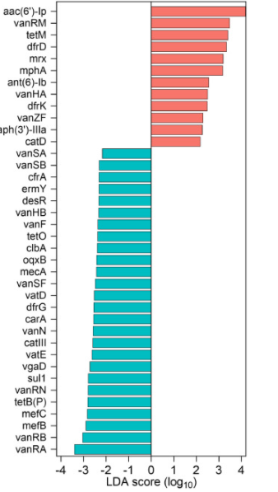

1. PMID - 25422753: *Antimicrobial susceptibility and analysis of macrolide resistance genes in Streptococcus pneumoniae isolated in Hamadan*
   1. The macrolide resistance genes of ermB and mefA were found in 10.9% and 18.2% of Clinical isolates of S. pneumoniae (n=55) collected from 400 outpaients samples
2. PMID – 29669883: Jocelyn OP study - *Impact of Long-Term Erythromycin Therapy on the Oropharyngeal Microbiome and Resistance Gene Reservoir in Non-Cystic Fibrosis Bronchiectasis*
   1. At baseline, the most commonly carried resistance gene was mef (detected in most subjects), while erm(B) (placebo = 53.6%, erythromycin = 60.5%) and erm(F) (placebo = 53.6%, erythromycin = 41.9%) were detected in approximately half of the subjects. Lower rates of carriage were observed for erm(C) (placebo = 17.1%, erythromycin = 11.6%) and erm(A) (placebo = 2.4%, erythromycin = 4.7%). msrA was detected in one subject at baseline
   2. Levels of both erm(B) and mef increased significantly between baseline and week 48 in the treatment group
3. PMID - 32994137: *Emergence of macrolide-resistant Streptococcus pyogenes emm12 in southern Taiwan from 2000 to 2019*
   1. In Taiwan from 2000 to 2019, study population: children with upper respiratory tract infection (URTI), 76.2% of them (93/122) carried ermB, 19.7%(24/122) carried mefA, 12.3% (15/122) carried tetO and 99.2%(121/122) carried tetM
4. PMID – 26989065: Tetracycline Antibiotics and Resistance
   1. Global tetracycline-resistance percentages were 8.7% and 24.3% for methicillin-resistant Staphylococcus aureus (MRSA) and Streptococcus pneumoniae, respectively (Mendes et al. 2015)
5. PMID - 27709102: *Macrolide Resistance in Streptococcus pneumoniae*
   1. Macrolide resistance gene distribution; the macrolide resistance gene carriage in different countries varied. E.g. In Australia, only 32.4 % of people carried ermB.
6. PMID: 15837373: while in most previous studies <10% of the Gram-negative isolates carried multiple tet genes [1], [8], [39]. This may be changing. One recent study of E. coli O157:H7 isolates found four (33%) of the 12 human Tcr isolates, with known tet genes, carried two different tet genes [19]. These studies suggest that multiple tet genes can represent >10% of the Tcr Gram-negative population in some ecosystems and this should be considered whenever characterization of tet genes are determined.
7. PMID: 19862477 : In a sampling for resistance determinants in diverse soils from various regions of the world, we showed a wide dispersion of antibiotic resistance, and the data on tetracyclines were informative [67]. Of 482 strains tested, 286 strains were found to be resistant to tetracyclines; ~60% of the strains in the sample.

**Prevalence of macrolide resistance gene in global**

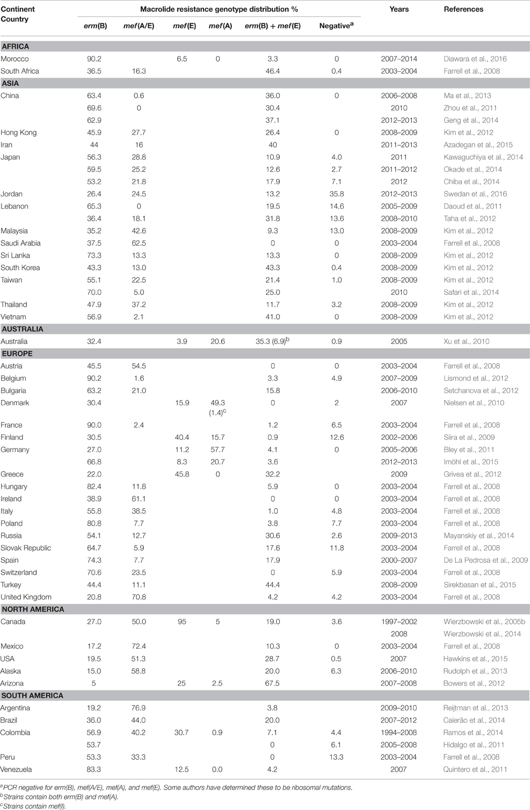

1. That “long-term term antibiotic macrolide therapy was not associated with increased risk of acquiring macrolide resistance genes”. A major shortcoming is that only macrolide/tetracycline resistance was assessed. Macrolide exposure can co-select for other resistance genes which may be an even greater concern (thinking of MDR plasmids etc.).

Tet genes are found on plasmids

Describe how you identified these genes

1. Further, the lung microbiome is relatively stable under antibiotic treatment and the gut is less so. The impact of macrolides on the gut may be much more relevant in terms of potential transmission of resistance. I understand that the focus is on the airway but what happens in the gut seldom stays in the gut, where resistance is concerned.

* matergut

In summary, the authors assess the impact of antibiotic therapy on macrolide/tetracycline resistance gene carriage/transmission in the airway and fail to detect a convincing signal that might suggest this is a real clinical problem. However, the study completely overlooks both other (non-macrolide/tetracycline) resistance mechanisms as well as the selective pressures placed on the intestinal microbiome and the risk of transmission of resistant gut pathogens. The authors have not sufficiently assessed this element and I’m concerned that it conveys a false message e.g. “macrolide selection is probably a non-issue”. Antibiotic selection in the gut (initially on commensal species) likely preceded the global dissemination of cephalosporinase resistance genes (i.e. CTX-M-15), for example. The effect of antibiotic selection in the airway and corresponding impact on AMR dissemination has yet to be concussively investigated. Thus, not looking at the gut, in the context of an AMR study is an oversight if onward transmission is the focus. Further the narrow range of analysis (10 genes) in the lung is a concern. Many other relevant resistance events could have been missed.

# Point to the strength of the study

# Cover letter could help

**Reviewer 3:**

The authors address the issue of whether long term macrolide therapy increases macrolide resistance and whether macrolide resistance increases in close contacts. There are a number of papers showing increased macrolide resistance and resistance genes with macrolide use, so the novelty lies in the issue of whether this spread.

1. I am not sure that clinical readers will understand the difference between gene detection and gene abundance, and perhaps some mention of qualitative vs quantitative or presence/absence vs total amount is appropriate for readers not familiar with microbiome work.

* We recognise this issue
* It is a complex issue where both contribute to our understanding
* We define these as … Within the author team, we have discussed this at length
* In response, we have [included definitions of each term]

1. For a clinical journal I think you need to put your data into a clinical context - what does all this mean in terms of clinically significant resistance in bacteria that would normally be treated by an oral macrolide (the real concern about community macrolide resistance). especially S.pneumoniae and other common streptococci.

* For discussion with Rachel and Lucy’s

1. There is no comment about whether the close contacts had administration of macrolides within a reasonable period (say 12 months) of sampling. With not vast numbers, this is a potential confounding variable.

* we included in online supplement

* This is an important feature of the study

* we have now moved this to the main text

1. With respect to the key issue of "does this resistance transfer to others, the key issue is whether the sample size is adequate to reach the conclusion of "no it doesn't". It is not defined what you would have considered sufficient gene transfer of resistance to be clinically or even epidemiologically relevant.

* Incidence where there was evidence of transmission (e.g. 2/53 times).

* HOW MANY TIMES DID “TRANMISSION” OCCUR

1. Given you did show erm and mef detection was more common in contacts of macrolide users, I am not clear at all how you can justify your conclusion that resistance is not trasnmissable into the community - in fact the opposite finding would appear to be supported by your data - as you acknowledge in your discussion. The last sentence of the abstract is therefore far too strong and not supported by your data.
   1. Within group showed ….
   2. Between group showed …
   3. We conclude “However, macrolide use was not associated with increased macrolide resistance gene detection rate and there was no evidence that long-term macrolide use increases the onward transmission risk to their close contacts.”
   4. Justify
2. In the discussion I think you have to note that the community data you have is an Australian context. Australia has seen much less use of oral macrolides, and especially problematic ones like Azithromycin, than has, for example, the US and hence international surveillance data typically shows much less clinical macrolide resistance in your population.

Get statistics

1. Very few of the close contact groups had any significant chronic lung disease. Do you think this may exert a protective effect on macrolide resistance transfer because they will not have as disordered a microbiome? We know that CF and bronchiectasis patients can and do transfer multi-resistant organisms to each other, but not to healthy contacts. This should at least be reflected on in the discussion.

**Statistical Review Comments:**

The primary objective of this prospective study is to estimate and compare macrolide resistance gene detection rates and abundances between MR, MNR, MRCC, and MNRCC cohorts. Study design, data collection, primary endpoints, and statistical methods were clearly described. Logistic regression models were used to associate cohorts with detection and transmission status. Results were presented adequately and clearly. Conclusions were drawn appropriately. I have one minor suggestion (not a concern or question):

1. Seems authors could try logistic GEE model to estimate and compare 4 cohorts (MR, MNR, MRCC, and MNRCC) in one model with respect of resistant genes detection. This would be more efficient than first comparing within treatment pairs then between treatment groups.

Bin

1. **Mughini-Gras 2019:** Humans to human transmission are the main source of community-acquired β-lactam-resistant E.coli
   1. Most community-acquired β-lactam-resistant E.coli carriage was attributed to human-to-human transmission within or between households in the open community (60·1%, 95% credible interval 40·0–73·5)
2. **Knox 2015_Trends in microbiology:** Several studies have highlighted the role of the household as the primary reservoir for S. aureus in the community 24, 25, 41, 43, 44, 45, 46, 47, 48, 49, 50, 51, 52, 53, 54, 55, 56, 57, 58. The events that follow a CA-MRSA infection in a household include an increase in: (i) the risk of infections among other household members 26, 44, 45, 48, 49, 50, 51; (ii) MRSA colonization among other household members 46, 47, 52, 53, 54, 55, 56, 57, 59; and (iii) contamination of environmental surfaces 24, 25, 58. These reports have described epidemic clones that ‘ping pong’ among family members 26, 51, resulting in high rates of recurrent infection. Eradicating S. aureus carriage from household members and the environment in an effort to reduce the frequency of these infections has achieved mixed results 60, 61.
3. Staphylococcus aureus nasopharyngeal carriage rates and antimicrobial susceptibility patterns among health care workers and their household contacts
4. Transmission of methicillin-resistant Staphylococcus aureus within a household
5. Prevalence of nasal colonization among patients with community-associated methicillin-resistant Staphylococcus aureus infection and their household contacts
6. Staphylococcus aureus nasal colonization among pediatric cystic fibrosis patients and their household contacts
7. Molecular epidemiology and household transmission of community-associated methicillin-resistant Staphylococcus aureus in Hong Kong